Contents
1. Introduction 2
2. Related Work 4
3. Data collection and Description 6
3.1 Primary Data 7
3.2 Secondary Data 12
4. Research Approach and Methodologies 14
4.1 Onion Model 15
4.1.1 Philosophy 15
4.1.2 Theory Development Approach 16
4.1.3 Methodological Choice 17
4.1.5 Time Horizons 18
4.1.6 Techniques and Procedures 19
4.2 Research Methodology 20
5 Results and Discussion 22
6 Conclusion and Recommendations 41
7 Reflections 42
7.1 Selected Research Methodology 42
7.2 Alternative Research Methodologies 43
7.3 Recommended Actions and Future Considerations 44
7.4 Recommended Methodology 45
References 50

Clustering-Based Customer Segmentation and Churn Analysis in the Telecommunications Sector Using Big Data Techniques
Feras Jalal¹ and Islam Alomari¹
¹ Al Hussein Technical University, Amman 11831, Jordan
22110173@htu.edu.jo, islamalomari@htu.edu.jo

Abstract
This study investigates the application of clustering algorithms for customer segmentation and churn analysis within the telecommunications sector using a real-world telecom churn dataset. The research applies data preprocessing, dimensionality reduction (PCA), and KMeans clustering to uncover customer patterns and evaluate cluster-specific churn behavior. The analysis is enhanced with survey data to complement model findings, offering a dual view of technical and stakeholder insights. Evaluation metrics including Silhouette Score, Calinski–Harabasz Index, and Davies–Bouldin Index were used to assess model performance. The findings indicate that behavior-based features like data usage and call frequency played a more significant role in segmentation than static demographics. This enabled the identification of high-risk customer segments and informed targeted retention strategies. The study concludes with recommendations for practical implementation and future work in explainable AI and proactive churn prevention.
Keywords: Clustering-based Churn Prediction, Customer Segmentation, Telecommunication

Introduction
One to two paragraphs about AI in general.
Artificial Intelligence, is the ability to programs and machines to perform tasks that usually require human intelligence like, reasoning, learning, and decision-making. AI seeks to give computers the ability to see patterns, learn from experience, and perform mental activities without direct guidance. There is a lot of AI techniques but there is one unique and most used technique is Machine Learning ML, it is a subset of AI it’s use is to make algorithms learn form data and discover the hidden rules and the relationships, without give it a pre-defined rules, this approach powers applications across industries—from recommendation systems and autonomous vehicles to healthcare diagnostics and fraud detection. AI systems can now find hidden patterns in big datasets because to the development of unsupervised learning, which includes clustering. This makes them particularly useful for pattern identification and exploratory data analysis (Sharma and Dey, 2012).

One paragraph about your specific topic in AI (i.e. in the field that is related to your research idea).
In the telecommunications industry, customer churn—the rate at which customers discontinue service, it is an important metric affecting profitability and competitiveness. Some researches have shown that using AI specifically ML to predict churn is crucial in making operators identify the potential churn customers. For example, using dataset of the customers and the appropriate ML model has improved churn detection. By using unsupervised machine learning grouping techniques such as clustering has given better results to enable retention plans to each churned group, (Sahoo et al., 2024).

One paragraph about your research question, and the objectives for this research, and illustrates your contributions clearly.

This study is guided by four core research questions: (1) What behavioral or demographic traits are most associated with customer churn in the telecommunications sector? (2) How can predictive models help in identifying churn-prone customers? (3) What operational and strategic improvements can be made using churn prediction insights? and (4) How do employees in different departments perceive the impact of churn prediction on their workflow? To address these questions, the study sets out several key objectives: to analyze how clustering algorithms can segment telecom customers based on churn-related behaviors; to collect and examine primary data from Zain Jordan customers related to churn indicators; to evaluate the effectiveness of clustering as a predictive and analytical tool for customer retention strategies; and to provide actionable recommendations for reducing churn using AI-driven insights. This research contributes to both academic understanding and industry practice by applying unsupervised machine learning methods to a real-world telecommunications context, integrating primary data obtained directly from users.

One paragraph describes the structure of the document. For example, it could be "Section 2 presents the related work. Section 3 discusses the data collection and description. Section 4 illustrates the proposed approach. Section 5 presents the experiments and results. Finally, Section 6 concludes the work and provides recommendation based on the conclusion."

This report is organized into several key sections to guide the reader through the research process and findings. Section 2 presents the related work, highlighting previous studies on churn prediction and the role of big data in telecommunications. Section 3 discusses the data collection process and provides a detailed description of the dataset used in the study. Section 4 illustrates the proposed methodology, including the research design, preprocessing steps, and clustering techniques applied. Section 5 presents the experimental results and discussions, integrating both code-based visualizations and survey findings to evaluate the outcomes. Finally, Section 6 concludes the report by summarizing the key insights and offering recommendations based on the research findings, while Section 7 provides personal reflections and considerations for future research directions.

Related Work
Two lines introduction about the field of the research papers that will be illustrated in this section. Summarize the papers that are relevant to your research. For example, each paper could be summarized in a 1-3 paragraphs summary that includes the methodology of the paper, its main result, the limitations or weaknesses of the paper. At the end, add a paragraph about the gap in the literature review that is addressed in your research work.
The fifteen related papers:
- Pejić Bach, M., Pivar, J. & Jaković, B. (2021). Churn Management in Telecommunications: Hybrid Approach Using Cluster Analysis and Decision Trees.
- Sahoo, S. et al. (2024). Customer churn modeling in telecommunication using a novel multi-objective evolutionary clustering-based ensemble learning.
- Xu, T., Ma, Y., Ao, C. et al. (2023). A novel telecom customer churn analysis system based on RFM model and feature importance ranking.
- Russo, F. et al. (2024). Enhancing customer retention in telecom with machine learning-driven churn prediction.
- Phua, C. et al. (2012). Predicting near-future churners and win-backs in telecommunications.
- Kasem Ahmad, A. et al. (2019). Customer churn prediction in telecom using machine learning and social network analysis in big data platform.
- Yang, L. et al. (2019). Prediction modeling and analysis for telecom customer churn in two months.
- Huang, Y. et al. (2013). Evolutionary churn prediction in mobile networks using hybrid learning.
- Sharma, A. & Dey, L. (2012). Comparative study of clustering techniques.
- Bose, I. & Chen, X. (2009). Hybrid models using unsupervised clustering for churn prediction.
- Sikri, A. et al. (2024). Adaptive ensemble learning approach for churn prediction.
- Sahoo, S. (2024). Explainer models for customer churn prediction.
- Imran Pathan et al. (2021). Adaptive learning system for telecommunication churn regression.
- Lopez Castillo, J. (2022). Telecom churn analysis using clustering techniques.
- Gupta, P. & Singh, R. (2023). Telecom churn prediction using machine learning optimization.

Top 3 most relevant papers:
- Pejic Bach, Pivar, and Jakovic (2021)

Methodology created a hybrid framework with three stages. The first stage using K-means clustering to segment customers. The second stage is to use Chi-square to identify high churn customers. The third stage is to use CHAID decision trees to explain churn determinants.

Main results, the hybrid framework improved accuracy better than the traditional approaches and gives better rules within each segment.

Limitations, this framework has only tested on a single dataset, There is little generality to other areas (such as Jordan).

- Sahoo et al. (2024)

Methodology, Designed to multi-objective evolutionary ensemble models (MOEEC-1 and MOEEC-2), ensemble model is a machine learning method known as an ensemble model combines several separate models, sometimes referred to as base models or learners, to provide a forecast that is more reliable and accurate than any one model by itself. Their approaches have combined between merging clustering and classification. This addressed class imbalance with an additional objective function.

Main results, MOEEC‑1 achieved 97.3% accuracy and 93.8% AUC; MOEEC‑2 scored 96.4% accuracy and 94.9% AUC—superior to benchmarks.

Limitations, this framework require complex parameters tuning and high computational power which are capable of increasing cost.

- Xu et al (2023)

Methodology, they have created a telecom churn analysis system by combining (RFM) Recency, Frequency, and Monetary. Recency refers to how recently a customer made a purchase, Frequency refers to how often the customer interacts or makes purchases, and Monetary refers to how much money the customer has spent. The combined RFM with the K-means algorithm, followed by a churn prediction using XGBoost and feature importance via SHAP. XGBoost stands for Extreme Gradient Boosting, It’s one of the most powerful and widely used machine learning algorithms for classification and regression tasks especially when performance matters.

Literature Review
A literature review surveys existing research to frame the current study, identify methodological best practices, and uncover gaps that this project seeks to address (Fraenkel & Wallen, 1990; Marshall & Rossman, 1989). This section explores how artificial intelligence (AI) and machine learning (ML), particularly clustering, have been used to address customer churn in the telecommunications sector. The review is organized thematically, covering hybrid models, interpretability, regional relevance, and unsupervised techniques.

Clustering and Hybrid Models for Churn

Pejić Bach et al. (2021) developed a three-stage hybrid framework combining K-Means clustering, Chi-square analysis, and CHAID decision trees. Their approach improved accuracy and provided interpretable churn explanations within each customer segment. However, their work was based on a single dataset and lacked regional applicability beyond its original market.

Sahoo et al. (2024) introduced MOEEC-1 and MOEEC-2, ensemble models that merged evolutionary clustering with classification to handle class imbalance in churn datasets. These models demonstrated outstanding accuracy (above 96%) but required significant computational power and tuning, limiting real-world usability.

Interpretability and Explainable AI

Xu et al. (2023) used the RFM (Recency, Frequency, Monetary) model combined with K-Means, XGBoost, and SHAP values to generate interpretable churn predictions. Their study reinforced the importance of incorporating explainability into AI models, especially for business users. However, the dataset used focused on purchasing behavior, which differs from telecom usage behavior.

Regional and Contextual Limitations

Many churn prediction studies, such as those by Phua et al. (2012), Gupta and Singh (2023), and Huang et al. (2013), rely on datasets from regions like India, the US, or Europe. These contexts may not reflect user behavior or telecom infrastructure in Middle Eastern markets. Very few studies integrate primary data from industry personnel or combine qualitative and quantitative perspectives on churn prediction.

Unsupervised Learning and Customer Segmentation

Several researchers (Bose & Chen, 2009; Sharma & Dey, 2012) emphasize the usefulness of clustering techniques in segmenting telecom customers. Clustering uncovers hidden patterns in customer behavior and can support targeted retention efforts. However, many of these studies stop at segmentation without further validating their insights through human or contextual interpretation.

Literature Gap.

Based on this review, two key gaps emerge:
(1) a lack of region-specific datasets and (2) minimal use of mixed-method approaches that integrate human insights into churn analysis. This study addresses both gaps by applying unsupervised clustering techniques to telecom customer data and supplementing the findings with primary survey data from Zain Jordan employees. Additionally, the research focuses on using interpretable, low-complexity AI models suited to telecom companies in the Middle East that may not have advanced data infrastructure.

This review establishes the theoretical and methodological foundation for the research and supports the need for localized, interpretable, and mixed-method churn prediction strategies.

Data collection and Description
Define the primary and secondary data and describe the differences between them.
data is commonly categorized as either primary or secondary, based on how it is obtained and its original purpose. Primary data describes original information that was gathered directly by the researcher for the particular goal of the present study, usually using instruments like surveys, interviews, or experiments. Conversely, Secondary data, such as publicly accessible datasets, official statistics, or published reports, are information that has already been gathered by others for a different purpose and then used for analysis in a fresh setting (Saunders et al., 2019).
The main difference is how directly the data is gathered: primary data gives you more control and value, but it may also take a lot of time or resources to obtain, while secondary data is usually easier to get and less expensive, but it could not be exactly what you need for your study.
Aspect | Primary Data | Secondary Data
Source | Collected Directly by the researcher | Collected by organizations
Purpose | Specific to the current study | Gathered for different objectives
Examples | Surveys, interviews, and experiments | Public datasets, reports, and academic articles
Advantages | High relevance and control over variables | Saves time, cost-wise
Disadvantages | Time-consuming, requires ethical approval | Could be outdated, or misaligned with the research objectives

3.1 Primary Data
- Describe your primary data (it could include figures and tables).
- Describe your experience in collecting your primary data. Include any issues you faced in this process.
- Justify your choice.
- Describe the merits and limits of primary data.

In this research, primary data was collected through a structured survey distributed via email to 11 employees from Zain Jordan. The survey was designed to explore employee perspectives on customer churn and the potential applications of AI-based churn prediction models. Although the survey included some questions on Big Data, this section focuses exclusively on responses related to churn. The survey included questions to target, Churn operational challenges, strategic decision-making supported by churn prediction, and Impact on customer experience, retention strategies, and data quality.

Based on the survey methodology applied in your research, the sampling technique used aligns with cluster sampling, which is a probability sampling method. In this study, the target population was composed of employees from different departments within Zain Jordan. Rather than randomly selecting individuals across the entire population, the participants were grouped into clusters based on their job functions—namely, big data and analytics experts, customer service staff, and marketing employees. A sample was then drawn from these predefined clusters to ensure representation from each functional group. This approach was both practical and structured, allowing for a cost-effective yet representative sampling of departmental perspectives, which was essential for addressing research questions related to cross-departmental views on churn prediction/

Due to low response rates, there were occasional delays during the survey's roughly two-week duration. The results provided valuable qualitative insights to supplement the quantitative clustering analysis, despite the tiny sample size.
This strategy was used in order to obtain direct input from business experts who deal with churn-related activities. Despite its small scope, the replies' depth and validity offered valuable background information on how telecom organizations view churn prediction.

Merits | Limitations
Relevant to the research questions | Time-consuming to collect about 2 weeks
Provides real contextual insights | Limited sample 11 responses
Offers qualitative understanding of churn patterns | It may includes biased opinions

Survey insights:
Figure 1: Which opportunity might the churn prediction model provide for improving customer retention?
Identifying at-risk customers was rated the most promising benefit of churn models by 45.5% of employees.
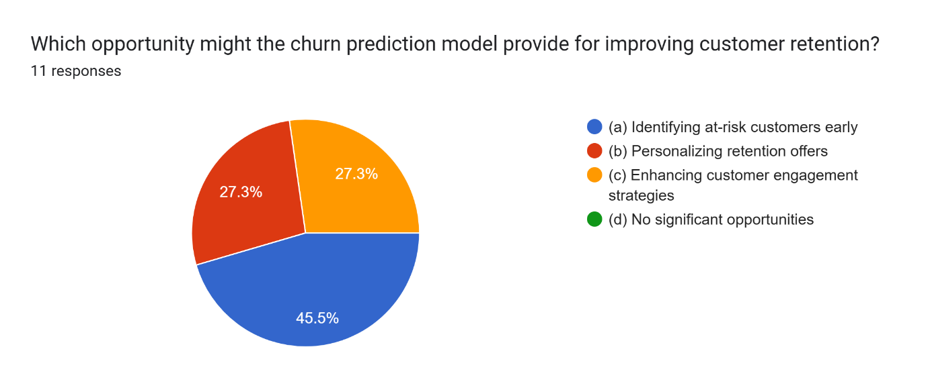

Figure 3.1.1

Figure 2: Which area of predictive analytics might the organization be interested in expanding to after implementing the churn prediction model?
Sales forecasting and customer segmentation were equally seen (36.4% each) as valuable predictive analytics extensions.
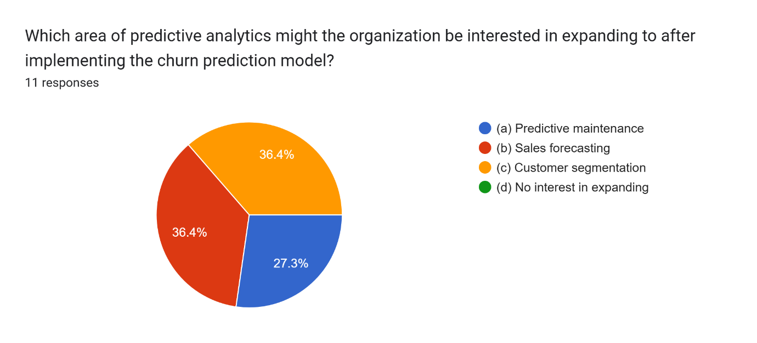

Figure 3.1.2

Figure 3: Which area of customer experience might be most improved by the churn prediction model?
54.5% believed churn prediction would mostly improve issue resolution time.
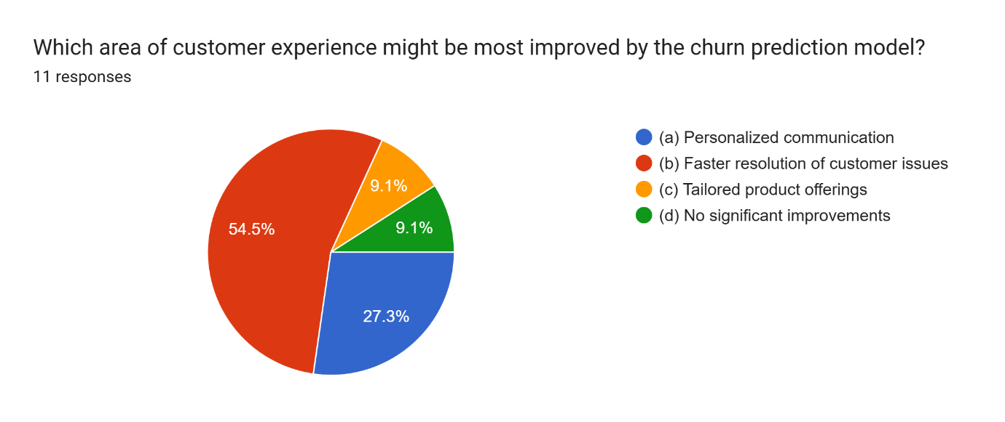

Figure 3.1.3

Figure 4: Which strategic decision-making area might benefit the most from insights gained through the churn prediction model?
Customer loyalty programs were considered the top strategic area that benefits from churn insights (63.6%).
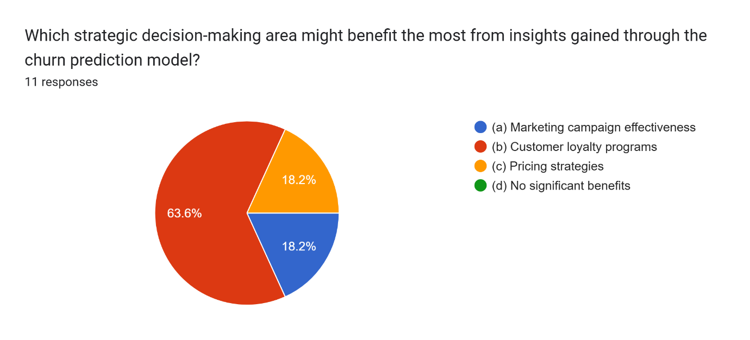

Figure 3.1.4

Figure 5: Which aspect of operational efficiency might be enhanced by using churn prediction?
Reducing acquisition costs was the leading operational efficiency gain (54.5%).
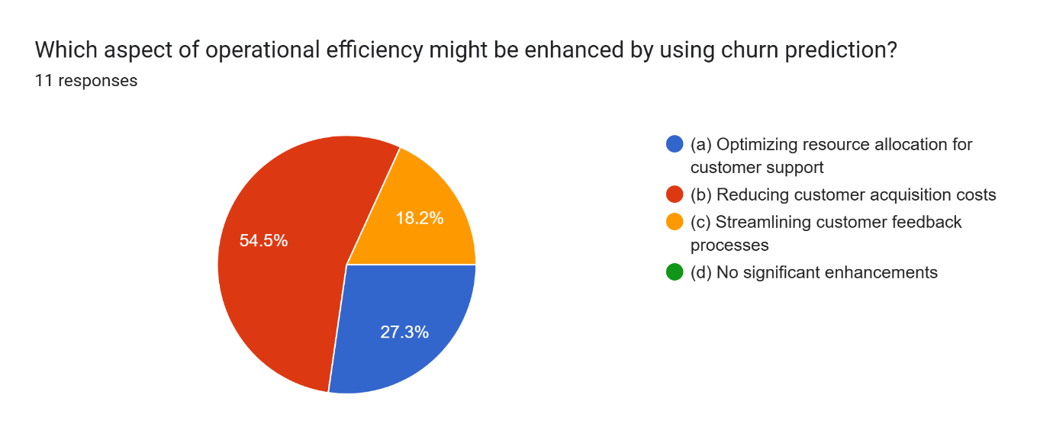

Figure 3.1.5

Figure 6: How would you rate the availability of customer data for churn prediction?
72.7% rated the availability of data as “Good.”
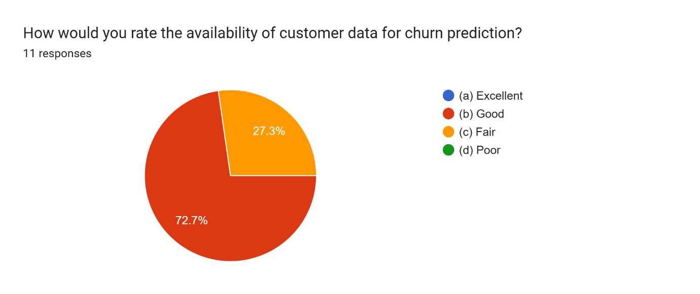

Figure 3.1.6

Figure 7: Does the organization have access to accurate and up-to-date customer behavior data?
Only 18.2% stated that their organization “always” has access to accurate and current behavioral data.
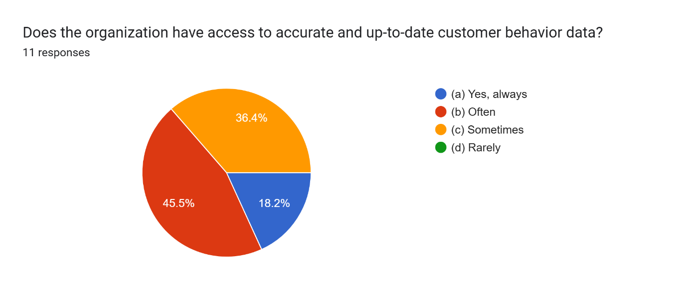

Figure 3.1.7

Figure 8: Which area of planning might be a challenge when acting on churn predictions?
Measuring the impact of actions taken was identified as the most common planning challenge (36.4%).
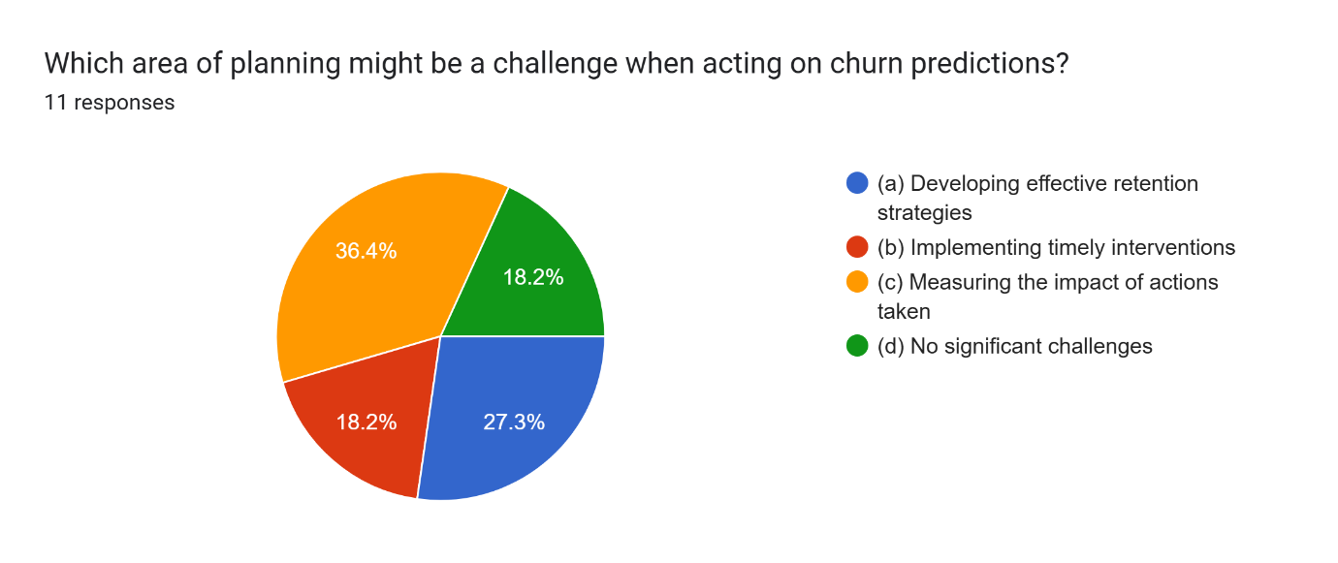

Figure 3.1.8

3.2 Secondary Data
- Describe your secondary data (it could include figures and tables).
- Justify your choice.
- Describe the merits and limits of secondary data.

Feature | Description
telecom_partner | The telecom company providing the service. Values include Reliance Jio, Vodafone, BSNL, Airtel.
gender | The customer’s gender: F = Female, M = Male.
age | Age of the customer in years. Ranges from 18 to 74.
state | The Indian state where the customer resides (e.g., Karnataka, Mizoram, Tamil Nadu).
city | City of residence (e.g., Kolkata, Mumbai, Delhi, etc.).
pincode | Regional postal code of the customer, indicating geographic location.
num_dependents | The number of financial dependents the customer has (e.g., children, elderly family members).
estimated_salary | The customer’s monthly income estimate in local currency (₹).
calls_made | Number of outgoing phone calls made by the customer during the period tracked.
sms_sent | Number of SMS messages sent by the customer.
data_used | Amount of mobile data consumed by the customer (likely in MB). Values must be cleaned (some are negative).
churn | Indicates if the customer has left the service: 0 = Retained, 1 = Churned (left the provider).
A publicly accessible telecom churn dataset, which included 243,553 customer records from many Indian telecom carriers (such as Jio, Vodafone, and BSNL), provided the secondary data used in this analysis. Customer age, gender, location (state and city), service consumption habits (calls, SMS, and data), number of dependents, and anticipated wage are among the demographic and behavioral characteristics included in the dataset.
Merits of the dataset:
- Large sample size 243K+ records, this ensures statistical reliability
- Mix of categorical and numerical features

Limitations of the dataset:
- Region-specific (India) and not representative of all global markets
- Requires cleaning (like outliers, categorical encoding)
- Categorical features like state and city may add noise if not carefully handled
- Churn column is dropped for clustering requires unsupervised evaluation only

Access and Ethical Considerations:
This study relying on both secondary and primary data sources. Ethical and access issues were carefully managed throughout the data collection and analysis process. For the primary data, access was granted through internal communication channels within Zain Jordan, targeting employees in customer service, marketing, and data analytics departments. Participants were selected using a cluster sampling method to ensure representation across relevant organizational roles. Participation was entirely voluntary, and informed consent was obtained digitally via the Google Forms survey interface. To ensure privacy and confidentiality, no personally identifiable information was collected, and all responses were anonymized. Additionally, participants were explicitly informed that they could withdraw at any point without penalty. Regarding the secondary data (the telecom_churn.csv dataset), ethical use was maintained by employing a publicly available dataset that contains no personal or sensitive information. During analysis, standard preprocessing steps such as data cleaning, encoding, and normalization were applied to protect data integrity and ensure reliable clustering outputs. All research activities conformed to institutional ethical guidelines, promoting transparency, data protection, and academic integrity throughout the study.

Research Approach and Methodologies
- State what is included in this section in one paragraph.
This section describes the methodology used in this study, which was based on the popular Research Onion Model given looking forward by Saunders et al. (2019). By addressing six essential layer research philosophy, approach and theory development, methodological choice, research strategy, time horizon, and methodologies and procedures the model offers an organized way for planning research. The potential possibilities for each layer of the onion are explored, and then the decisions selected to meet the goal of this study using AI-based clustering to investigate customer retention in the telecom industry are clearly justified.

Onion Model

Describe the onion model.

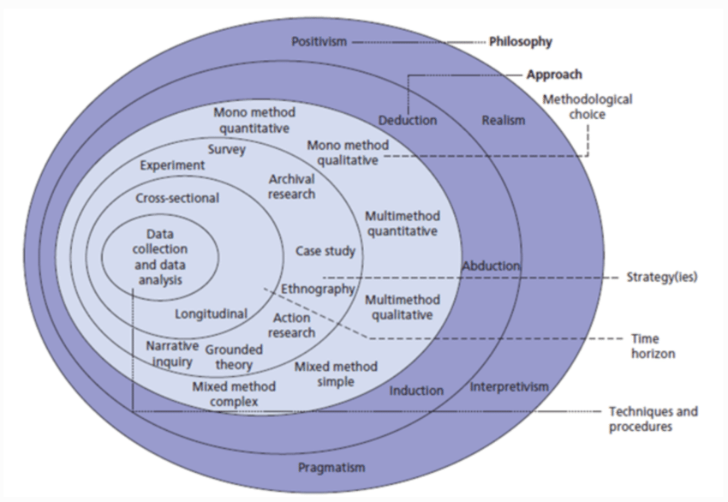
Figure 1: The structure of the Onion Research Model [1].

Philosophy

- Discuss different research approaches and methodology for the Philosophy layer. Provide justification of your choice.

The research philosophy, which outlines the researcher's viewpoint and knowledge development, is the outermost layer of the research onion. There are 5 main philosophical positions:

Positivism: believes that reality is objective and open to scientific observation, measurement, and measurement. It is frequently linked to numerical data and hypothesis testing.

Interpretivism: focuses on understanding the experiences and meanings behind social phenomenon, usually using qualitative methodologies.

Critical realism: This suggests that behind structures and mechanisms that are not always easy to measure have an impact on observable results.

Postmodernism: challenges fixed truths and accepts other viewpoints, frequently highlighting conflict and complexity.

Pragmatism: focuses on practical outcomes and adopts a flexible approach to method selection based on the research question.

Justification:
For this study positivism has been chosen as the research philosophy and this done for reasons such as the study relies on empirical, measurable, and numerical data, this includes survey questions and secondary dataset to reveal hidden patterns in customer churn, also the use of clustering technique is aligned with positivism because it focuses on systematic analysis and observation, for these reasons positivism is the most suitable philosophical approach for achieving the main objective.

Theory Development Approach

- Discuss different research approaches and methodology for the Development Approach layer.
- Provide justification of your choice.

The second layer of the onion model focuses on the strategy for developing theories, and how the researcher links previous information to the research process, there are three approaches:

Deductive: starts with an established theory or hypothesis and uses the facts gathered to test it. It is helpful when factors are measurable and obvious, and it is frequently linked to quantitative research.

Inductive: involves gathering information first, then using patterns found to guide the development of a new hypothesis. It is usually employed in qualitative research when adaptability and investigation are necessary.

Abductive: blends induction and deduction. It begins with an observation, iterates between facts and theory, and looks for the best explanation.

Justification:
For this research, the choice is deductive approach and this approach has been chosen for multiple reasons, first the study begins with establishing theories on customer churn and AI models especially ML this has been extracted for, the literature review, Both the main survey's structure and the clustering methods used on the secondary dataset were influenced by those views. The deductive technique is most suited for this study as the objective is to examine existing ideas in an organized, data-driven manner rather than coming up with new hypotheses.

4.1.3 Methodological Choice

- Discuss different research approaches and methodology for the Methodological layer. Provide justification of your choice.

The third layer of the onion model is the methodological choice, it refers to the design of the data types are used to conduct the study. There are three general approaches:

Mono method: involves using single method either to use qualitative or quantitative. Qualitative like interviews or case studies
Quantitative like interviews

Multi-method: Uses more than one data collection technique and analysis procedure, within the same methodological type
Multiple quantitative: uses multiple quantitative methods
Multiple qualitative: uses multiple qualitative methods

Mixed method: combines both quantitative and qualitative approaches at the same time

Simple mixed: equal use of both quantitative and qualitative approaches
Complex mixed: one dominant approach and the other is supporting it

Justification: The quantitative mulyi method approach was chosen. Both primary data (from Zain employee surveys) and secondary data (a large telecom dataset used for clustering) are numerically analyzed in this study. Quantitative methods based on statistical computing, including silhouette evaluation and K-means, are used to construct clustering models. Despite the contextual information in the survey, the data was examined in a formal manner (charts and percentages) without a thorough qualitative analysis. As a result, the nature and objectives of this study are best served by a quantitative mono-method design.

Research Strategy

- Discuss different research approaches and methodology for the Strategy layer.
- Provide justification of your choice.

The fourth layer of the onion model is the research strategy, it refers to the main plan used to answer the research questions and achieves the objectives of the study. There are multiple methods:

Survey: collecting data from sample using questionnaire
Case study: a detailed examination on in small entities but this established deeply on the small portion of the entities.

Experiment: testing multiple hypothesis under defined circumstances.

Archival research: depends on the analysis and examination of the current database

Ethnography: used to focus on cultural insights by searching in group of people

Action research: an involvement strategy, the researcher is dedicated to solve a problem by himself

Grounded theory: develops or creates new theories from existing data

Narrative inquiry: finds and explores experiences from personal stories and narratives

Justification: the used approach will be a combination of survey and archival research. The survey was used to gather primary data from employees of Zain Jordan, focused on perceptions and practices related to customer churn. This method provided first-hand insights and was appropriate given the structured nature of the questions and the need for quantitative analysis.
Furthermore, archival research was applied through the use of a publicly available secondary dataset from the telecommunications sector. This dataset was used for clustering experiments to discover behavioral patterns associated with customer churn. This hybrid approach met the overall quantitative and positivism design of the research.

Time Horizons

- Discuss different research approaches and methodology for the Time Horizons layer. Provide justification of your choice.

The fifth layer in research, the time horizon is the period of time that the study is carried out and the data is gathered. There are two approaches:

Cross-sectional: data is collected at a specific single point. This approach is mainly used in academic research, and it includes limited timeframes

Longitudinal: data is collected over long period of time so the observations that happened affecting by time is collected specially in trends analysis.

Justification: for my study the cross-sectional approach is the chosen due several points, first one that the primary data Zain JO’s survey and the secondary data the churn dataset both were collected and analyzed in a specific time frame. This approach is consistent with the project's scope and academic timeline, which focuses on producing insights within a limited period. Also the approach us used to determine and discover the current pattern not to observe the changes in customers behavior over time.

Techniques and Procedures

- Discuss different research approaches and methodology for the Techniques and Procedures layer.
- Provide justification of your choice.

The last and the inner layer of the onion model is techniques and procedures, it refers to using some techniques to collect, prepare, and analyze data. The techniques that are used in my study are quantitative deductive and positivist, with a focus on predictive insights and discovering hidden patterns.

Primary data: A structured survey that was given to Zain Jordan staff members was used to gather the primary data. Google Forms was used to collect responses Descriptive statistics and visualizations (such as pie charts) were then used to examine the data in order to identify important trends in how people see customer churn, including the expected advantages, difficulties, and accessibility of data.

Secondary data: The secondary dataset was sourced from a publicly available telecom customer churn dataset. The data was preprocessed using Python and libraries such as Pandas, Matplotlib, and Scikit-learn. Preprocessing steps included:

- Handling missing values and duplicates
- Converting categorical features to numerical format(encoding)
- Normalize continuous features
- Select the most features that contribute to customer churn

Clustering techniques: To explore customer segments, unsupervised machine learning techniques were applied, clustering techniques unsupervised ML.

Applying multiple clustering algorithms to group customers base on their behaviors, calculate evaluation metrics to see the performance of each algorithm, then establish a cluster analysis to identify at-risk customers

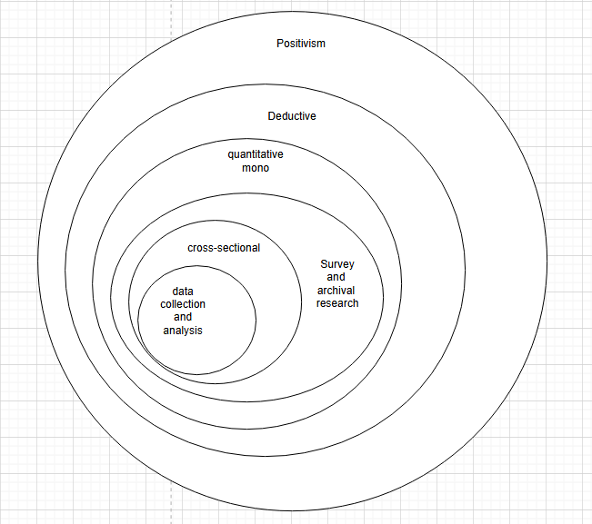

Figure 4.1.6.1 Onion Model

Research Methodology
- Use a chart to show how your work is completed and discuss each part of the chart. An example of a chart is shown in Figure2.

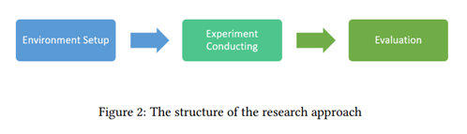
Critically evaluate each part of the chart to justify chosen research methods and analysis.

Environmental Setup:

The environmental setup includes the tools, libraries, and preprocessing techniques utilized to prepare the dataset for experimentation. This research was conducted using Python as the primary programming language, with google colab as the development environment. The following libraries were used:
- Pandas for data manipulation and cleaning
- NumPy for numerical operations
- Scikit-learn for preprocessing, clustering algorithms, and evaluation metrics
- Matplotlib and Seaborn for data visualization

The telecom_churn.csv dataset, which once had data columns like customer_id and date_of_registration along with category and numerical attributes, was used. These were eliminated in order to guarantee that only essential attributes were included in the analysis during the first cleaning stage. The data was preprocessed in a number of ways:

- Missing values handling, by removing records that contains null values
- Categorial columns encoding, use one-hot encoding to convert categorical columns to numerical
- Feature scaling, using StandardScaler to normalize features to ensure balance influence for each column

Experimental Conducting:

the goal of the experimental phase was to segment telecom users into meaningful clusters based on behavioral and demographic features. The following steps were taken to carry out the clustering experiment:

- Clustering algorithm: used K-Means has been chosen as it showed in the elbow method plot the optimal number of clusters is 7

- Dimensionality reduction: used principal component analysis to improve clustering and to support visualization. It reduced the feature space by retaining most variance features (setting 10 components)

- Cluster profiling cluster centroids were analyzed to extract meaningful insights, patterns based on telecom operator usage, city of residence, and salary ranges were identified across the 7 clusters, this helped in interpreting customer behaviors and forming hypotheses on potential churn drivers.

Evaluation:

The evaluation phase focused on assessing the quality and interpretability of the generated clusters using both quantitative and qualitative criteria:

The effectiveness of clustering was assessed using multiple internal validation metrics. The Silhouette Score, which measures the quality of clustering, was 0.11 on the original feature space. After applying PCA, it improved to 0.18, indicating enhanced cohesion and separation among clusters. The Calinski Harabasz Index was 15114.6, suggesting strong inter-cluster dispersion and intra-cluster compactness. Meanwhile, the Davies–Bouldin Index was 1.75, which, although not optimal (lower is better), remains acceptable given the complexity and overlapping nature of customer behavior in real-world scenarios.

Results and Discussion
- Discuss the results. Include all tables and figures.
- Explain how the results meet the research question and objectives.
- Describe merits and limits of the analysis.

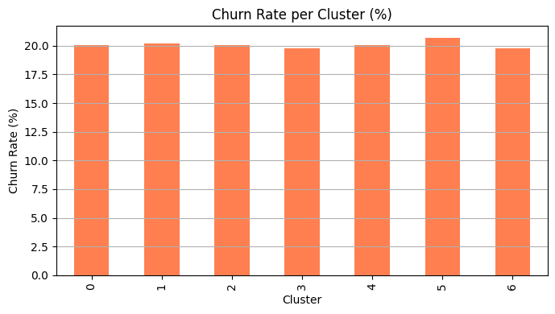

Figure 5.1
This bar chart displays the churn rate (%) across the 7 identified customer clusters. Each bar represents one cluster, and the height of the bar shows the percentage of customers within that cluster who have churned.
Churn rates range approximately between 19.6% and 20.7%. The highest churn rate is observed in Cluster 5, slightly above 20%. The lowest churn rate appears in Cluster 1 and Cluster 6, around 19.7%.

How this contributes to the research objectives:
- Addresses Research Question "Which customer segments are most likely to churn?"
By segmenting the customers into clusters and comparing churn rates, this chart directly highlights which group is more vulnerable. Although churn rates are fairly uniform, the slight variations suggest nuanced behavioral or demographic differences between clusters.
- Support objective "Identify and analyze customer segments to improve retention strategies."
Knowing that Cluster 5 has the highest churn rate helps the organization prioritize retention efforts for this group. This insight allows targeted interventions like personalized offers, increased support, or better engagement for that specific cluster.

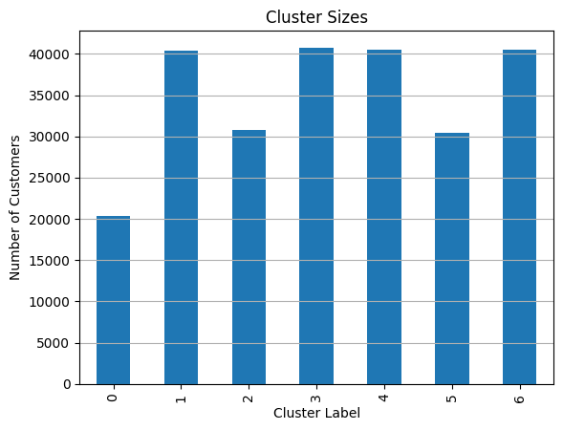

Figure 5.2

This bar chart shows the number of customers within each of the 7 identified clusters. The x-axis represents the cluster labels (0 to 6), while the y-axis indicates the number of customers in each group. The chart reveals that Clusters 1, 3, 4, and 6 have the highest customer counts, each slightly above 40,000. Clusters 2 and 5 are moderately sized, with just above 30,000 customers. Cluster 0 has the smallest population, containing around 20,000 customers.

- Addresses Research Question "How are telecom customers distributed across behavioral clusters?"
This plot directly illustrates the distribution of customers across different segments. By showing the relative sizes of clusters, it informs the company which segments are most prevalent in the dataset and may require more focus.

- Supports Objective “understand customer base segmentation to tailor service strategies””
Identifying which clusters have a larger customer base enables the business to allocate resources accordingly. For instance, targeting retention or upselling strategies to large clusters like 3 or 4 may yield higher returns. Meanwhile, smaller segments like Cluster 0 might represent niche customers requiring specialized services.

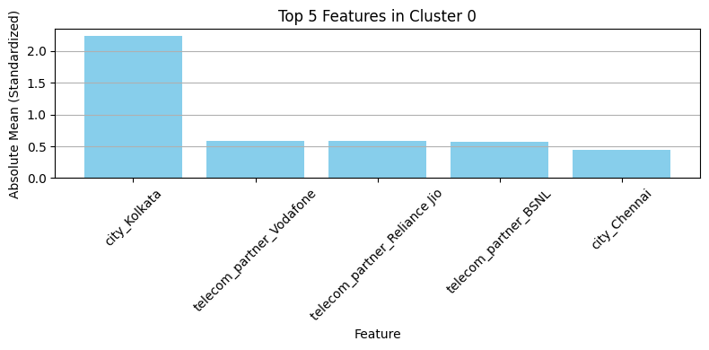

Figure 5.3

This bar chart displays the top 5 distinguishing features for customers in Cluster 0 based on their standardized absolute mean values. The x-axis lists the most influential features, while the y-axis represents the strength of these features' contribution to cluster separation. The dominant feature is city_Kolkata, with a significantly high score above 2.0, indicating that customers in Cluster 0 are predominantly based in Kolkata. Other contributing features include usage of Vodafone, Reliance Jio, and BSNL as telecom partners, with moderate influence. city_Chennai appears with a slight negative influence, possibly indicating lower representation from that region.

- Addresses Research Question "What characterizes each customer cluster?"

This chart reveals that Cluster 0 is geographically and operator-specific — primarily composed of Kolkata-based customers using Vodafone and other telecom partners. It helps identify unique traits of each segment beyond generic demographics.

- Supports Objective "Identify and analyze customer segments to improve retention strategies."

By understanding the profile of Cluster 0, the organization can craft location- and operator-specific marketing strategies. For example, retention campaigns targeting Vodafone users in Kolkata could be prioritized for this segment.

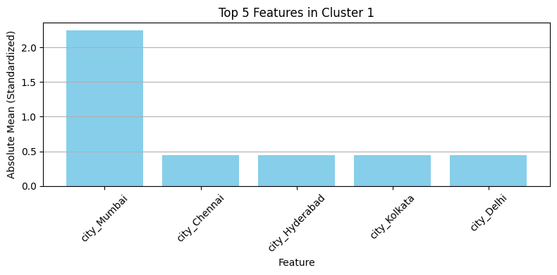

Figure 5.4

This bar chart highlights the most significant features that characterize Cluster 1 based on their standardized absolute mean. The dominant feature is city_Mumbai, followed by city_Chennai, city_Hyderabad, city_Kolkata, and city_Delhi.
Interpretation of Results:
Strong Geographic Identity: The cluster is strongly defined by geography, especially Mumbai, which has the highest weight, suggesting a concentration of customers in that city.
City Diversity: The remaining features are also cities, implying that Cluster 1 is grouped primarily by regional attributes rather than behavioral or telecom usage traits.

- Addresses research question “What traits define different customer segments?"
Cluster 1 is primarily shaped by location, indicating that city-based segmentation is a major differentiator in the dataset.

- Supports the Objective "Identify and analyze customer segments to improve retention strategies."
Since this cluster includes users from several major cities, telecom providers can design city-specific marketing or support programs, especially in Mumbai, which is the most influential city in this segment.

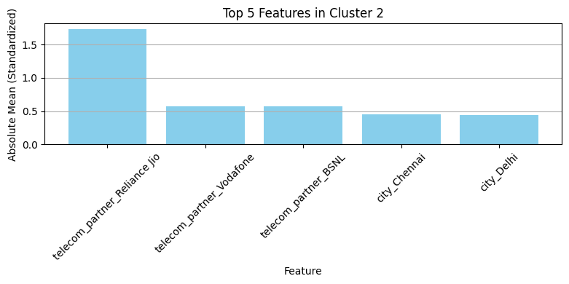

Figure 5.5

This bar chart displays the top 5 standardized features defining Cluster 2. The most prominent is telecom_partner_Reliance Jio, followed by telecom_partner_Vodafone, telecom_partner_BSNL, city_Chennai, and city_Delhi.

Interpretation of Results:

Service Provider Driven: The dominant traits in this cluster are related to telecom partnerships, indicating that network provider plays a stronger role than geography in shaping this segment.

Multiple Operators: The presence of three major providers (Reliance Jio, Vodafone, BSNL) suggests that these customers may have distinct usage patterns or satisfaction levels related to these networks.

Mild Geographic Presence: Cities like Chennai and Delhi also appear, but with lower weight, indicating that location plays a secondary role.

- Addresses the Research Question "What traits define different customer segments?"

Cluster 2 is clearly influenced by the customer’s telecom provider, especially Reliance Jio, which may reflect differences in pricing, coverage, or service quality.

- Supports the Objective "Develop insights to inform personalized customer engagement strategies."

Since telecom partner is a key trait here, companies can target customers based on their provider affiliation offering upgrades, retention plans, or competitor-switching incentives specific to users with Reliance Jio or Vodafone.

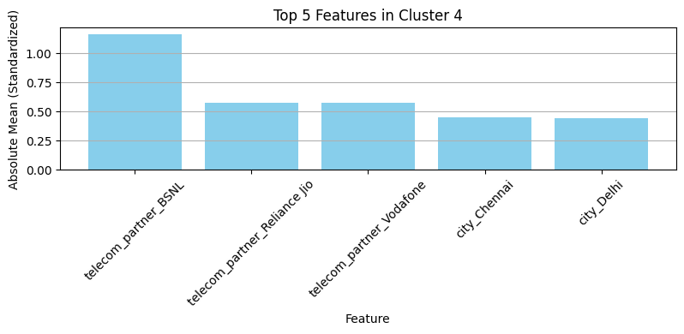

Figure 5.6

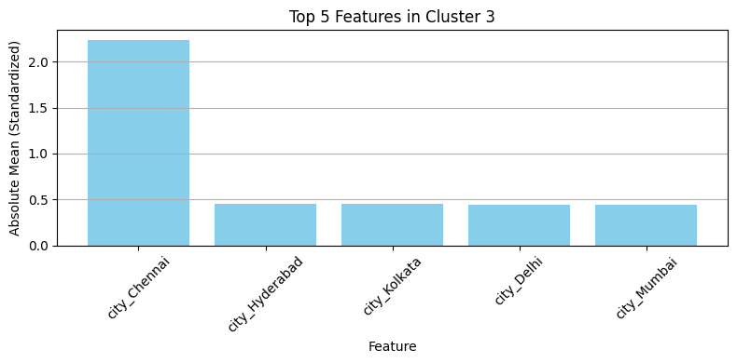

Figure 5.7

This bar chart displays the top 5 standardized features defining Cluster 3. The most distinguishing feature is city_Chennai, followed by city_Hyderabad, city_Kolkata, city_Delhi, and city_Mumbai.

Interpretation of Results:

Location-Dominant Cluster: All five features are cities, with Chennai having the strongest presence. This indicates that Cluster 3 is geographically defined.

Pan-India Urban Representation: The mix of major cities implies that customers in this group are distributed across key urban centers, but the concentration is highest in Chennai.

- Addresses the Research Question "What traits define different customer segments?"

This cluster is heavily location-based, showing that city of residence is a key distinguishing factor for this group.

- Supports the Objective "Identify segment-specific engagement and marketing opportunities."

The company can leverage localized strategies for customers in Chennai and other cities, such as city-specific promotions, service bundles, or regional events to boost retention and engagement.


Figure 5.7

This bar chart presents the top 5 standardized features that define Cluster 4. The most dominant feature is telecom_partner_BSNL, followed by telecom_partner_Reliance Jio, telecom_partner_Vodafone, and two location-based features: city_Chennai and city_Delhi.

Interpretation of Results:

Partner-Based Segmentation: The most influential traits are associated with telecom partners especially BSNL, which shows the highest absolute mean in this cluster.

Mixed Telecom Usage: The presence of multiple telecom providers suggests these customers may have diverse connectivity needs or preferences.

Urban Presence: While not the primary factor, the cities Chennai and Delhi are still notable, indicating that a portion of this cluster resides in major metropolitan areas.

- Addresses the Research Question "What traits define different customer segments?"

This plot indicates that network provider loyalty or preference is a key segment differentiator, particularly BSNL.

- Supports the Objective, "Customize retention efforts based on user profiles."

By knowing that this cluster has a strong association with BSNL users, the company can collaborate with BSNL or design co-branded campaigns, retention offers, or service upgrades specifically for these users.

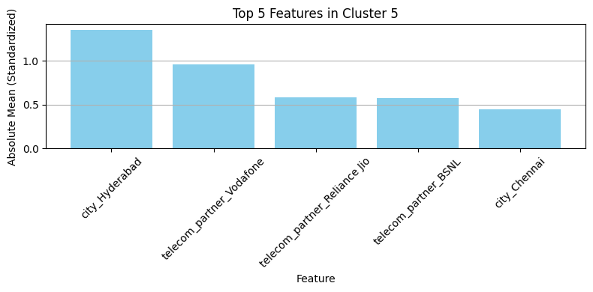

Figure 5.8

This bar chart visualizes the top 5 standardized features that define Cluster 5. The most impactful features include, This bar chart illustrates the top five standardized features that characterize Cluster 5. The most influential factors include a strong presence of customers from Delhi and Hyderabad, as well as significant associations with three major telecom providers: Vodafone, Reliance Jio, and BSNL. This combination suggests that Cluster 5 represents a highly urbanized and service-diverse segment, where users are likely exposed to multiple operator options and may exhibit flexible or competitive behavior in their telecom preferences.

Interpretation of Results:

Urban Dominance: The cities Delhi and Hyderabad are strongly represented, pointing to this cluster's urban user concentration.

Diverse Operator Usage: This group is notable for being strongly affiliated with three different telecom partners Vodafone, Reliance Jio, and BSNL, which indicates a highly competitive or flexible user segment.

- Addresses the Research Question, "Which demographic or behavioral traits define churn-prone segments?"

While this cluster doesn't directly show churn, the diversity of telecom partners used suggests these users may be comparing services or switching, indicating churn risk.

- Supports the Objective, "Develop targeted churn prevention strategies."

The presence of multiple telecom providers within this cluster suggests that these users might be evaluating different services. Retention strategies could include bundling offers or loyalty programs tailored to their usage behaviors.
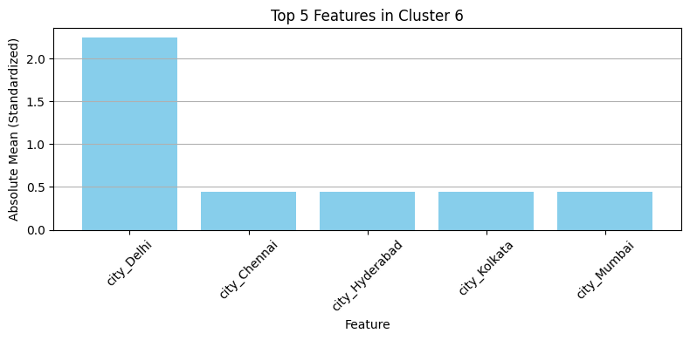

Figure 5.9

This bar chart illustrates the top five standardized features that characterize Cluster 6. The most influential factors include strong associations with the telecom providers Vodafone, Reliance Jio, and BSNL, along with notable customer presence in Delhi and Kolkata. This combination suggests that Cluster 6 consists of users located in key metropolitan areas who have exposure to multiple service providers, reflecting a competitive or flexible telecom environment.

Interpretation of Results:

Metropolitan Concentration: The cities of Delhi and Kolkata are prominently represented, indicating a strong urban customer base.

Multi-Provider Engagement: The presence of all three major telecom operators within this cluster implies a customer group that is likely comparing or switching between services, pointing to high market competition.

1. Addresses the Research Question, "Which demographic or behavioral traits define churn-prone segments?"
Although this cluster doesn’t directly correlate with the highest churn, the users’ engagement with multiple providers indicates potential churn behavior due to service evaluation or dissatisfaction.

2. Supports the Objective, "Develop targeted churn prevention strategies."
Retention efforts should focus on reinforcing brand loyalty among these users through exclusive offers, bundled services, or customer experience enhancements to discourage switching behavior.

Modeld effectiveness and evaluation metrics:

Clustering model K-Means used with 7 clusters, number of clusters was determined by the elbow method. Dimensionality reduction was applied specially principle component analysis PCA (10 components) PCA improved the clustering performance.

Silhouette Score = 0.18 | Clainski-Harabasz = 15114.69 | Davies-Bouldin = 1.75
indicates moderate cohesion and separation among clusters. | a high value signifying dense intra-cluster similarity and well-separated inter-cluster distances. | while not very low, this is acceptable in customer segmentation tasks where behaviors often overlap.
The silhouette score is frequently used to assess clustering performance in the context of customer churn prediction in the telecom industry. Real-world datasets, particularly those involving consumer behavior, typically provide low scores, even if values closer to 1 suggest dense and well-separated clusters. Because customer profiles and usage patterns overlap, previous research has demonstrated that a silhouette score of around 0.4 is regarded as a strong result for churn-related segmentation (Verma et al., 2021).

Feature importance was inferred by finding the top key reasons that affect each cluster, for example cluster 5 shows that it hugely effected by the presence in Delhi and the use of multiple telecom providers. Cluster 6 showed that it is has a strong association with customers in Delhi and Kalakota. These clusters help interpret how location and telecom partner preference shape customer behavior, which is crucial for targeted marketing.

Misclustering and Limitations:
There is some indication that the feature patterns and turnover rates of different clusters overlap. Churn percentages, for example, varied relatively little (~19.6% to ~20.7%) amongst clusters. This implies:
Misclustering Risks: Users with similar behavioral traits might fall into different clusters due to noise or overlap.
PCA loss: While PCA improved silhouette score, it may have reduced feature interpretability due to transformation into abstract components.

Real-world applications:
- Churn Prevention: Identifying churn-prone clusters (e.g., Cluster 5) enables customized retention campaigns.
- Customer Profiling: Understanding which segments use which telecom services supports targeted bundling and upselling.
- Service Optimization: Telecoms can improve infrastructure in areas (like Delhi or Hyderabad) where multiple providers attract competitive user bases.
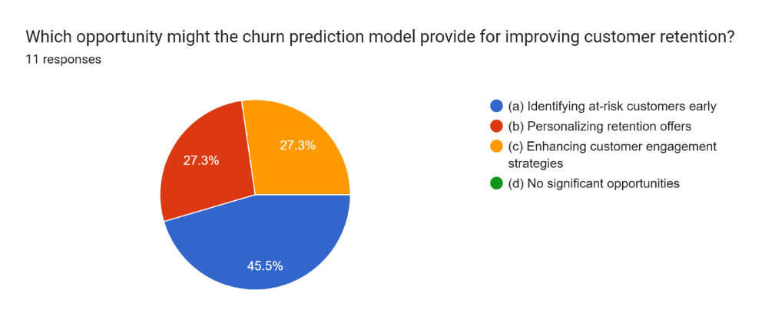

Figure 5.10

The pie chart presents responses to the question: "Which opportunity might the churn prediction model provide for improving customer retention?" Out of 11 participants, the largest segment (45.5%) selected (a) Identifying at-risk customers early, followed equally by (b) Personalizing retention offers and (c) Enhancing customer engagement strategies, each with 27.3%. No respondent selected (d) No significant opportunities, indicating a general belief in the model’s strategic value.

Interpretation of Results:
Most respondents recognize early identification of at-risk customers as the most valuable opportunity, which aligns directly with one of the core goals of churn prediction systems. The nearly equal support for personalization and engagement strategies reflects an understanding that churn mitigation is multifaceted, requiring both proactive detection and reactive engagement.

Research Question: What are the most effective opportunities offered by churn prediction models in the telecom sector?
This chart clearly indicates that stakeholders prioritize proactive detection (i.e., early warning systems), which confirms that predictive modeling is perceived not just as diagnostic, but also action-oriented in a commercial setting.

Objective: Assess opportunities of big data and predictive models in improving customer retention strategies.
The results demonstrate stakeholder confidence in the potential of big data models to deliver targeted retention actions especially in flagging high-risk users and tailoring retention plans. This supports the argument that big data and churn prediction tools can translate into real strategic interventions.

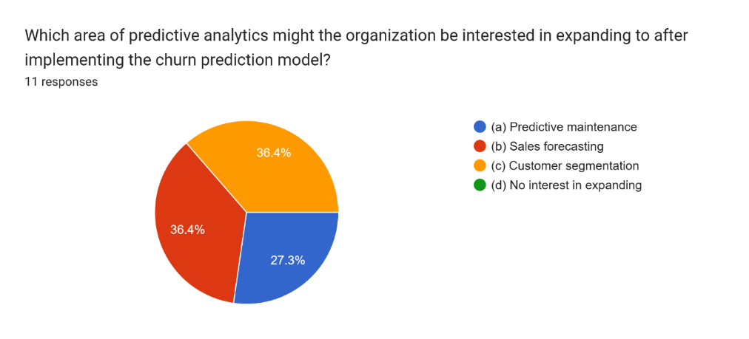

Figure 5.11

This pie chart visualizes responses to the question: "Which area of predictive analytics might the organization be interested in expanding to after implementing the churn prediction model?" Out of 11 participants, 36.4% selected (b) Sales forecasting, 36.4% selected (c) Customer segmentation, 27.3% chose (a) Predictive maintenance, No participants chose (d) No interest in expanding.

Interpretation of Results:
The equal preference for sales forecasting and customer segmentation highlights a strong interest in using predictive analytics beyond churn. These results imply that once a churn model proves useful, stakeholders expect broader analytics to optimize both revenue (through forecasting) and customer understanding (via segmentation). The lower but notable support for predictive maintenance suggests some interest in infrastructure or operational optimization.

Research Question: How might predictive analytics evolve within the organization beyond churn modeling?
The chart suggests that telecom organizations view churn prediction as a gateway to a broader predictive ecosystem. The transition into sales and customer-focused modeling reflects a demand for expanding insights across business functions.

Objective: Explore the broader role of big data analytics beyond churn prediction in telecommunications.
The survey results indicate that stakeholders see value in scaling analytics solutions, especially those aligned with business growth and customer intelligence. The absence of responses under “no interest in expanding” reinforces the perceived potential of predictive analytics as a core enabler of innovation.

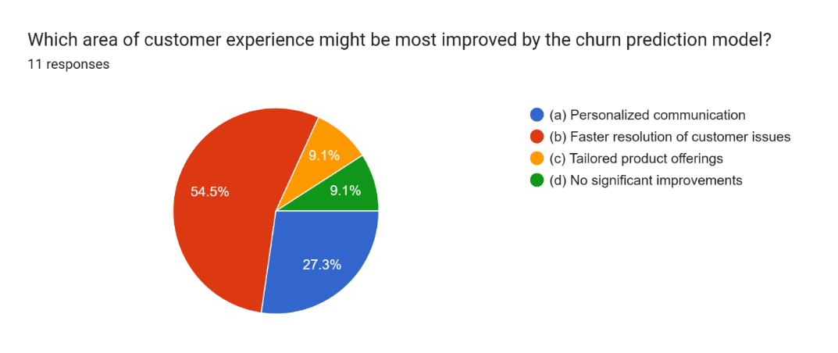

Figure 5.12

This pie chart presents the responses to the question, “Which area of customer experience might be most improved by the churn prediction model?” based on feedback from 11 participants. The majority, 54.5%, believed that the churn prediction model would most significantly enhance faster resolution of customer issues. Meanwhile, 27.3% indicated that personalized communication would benefit the most, whereas 9.1% selected tailored product offerings. Another 9.1% of respondents felt that the model would not bring any significant improvements to customer experience.

Interpretation of Results:
The majority of participants (54.5%) believe that faster issue resolution would benefit most from a churn prediction model, suggesting that anticipating customer frustration allows organizations to proactively resolve problems. The second-highest choice, personalized communication, indicates recognition of churn models as tools for improving messaging relevance. Fewer respondents saw significant impact in tailored product offerings, and only a small minority doubted any improvement at all.

Research Question: How can churn prediction improve the customer experience?
This chart clearly supports the view that proactive support, such as resolving customer issues before escalation, is seen as the top benefit. This aligns with the expectation that early warnings of churn risk allow for operational improvements in service delivery.

Objective: Assess the potential customer experience enhancements enabled by big data analytics.
The results underscore that reactive service models can shift towards proactive engagement using analytics. Fast issue resolution and personalized interactions suggest that organizations can turn churn prediction from a purely strategic tool into an operational enabler of better service.

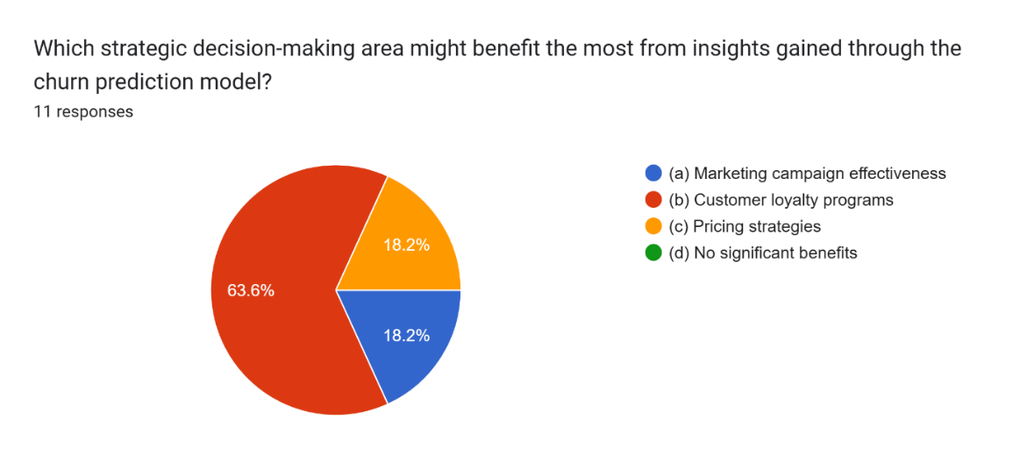

Figure 5.13

This pie chart presents the responses to the question, “Which strategic decision-making area might benefit the most from insights gained through the churn prediction model?” based on feedback from 11 participants. The majority, 63.6%, indicated that customer loyalty programs would benefit most. Meanwhile, 18.2% selected marketing campaign effectiveness, and another 18.2% chose pricing strategies. No respondents believed there would be no significant benefits.

Interpretation of Results:
Most participants believe that churn prediction would have its strongest strategic impact on customer loyalty initiatives, suggesting that predictive insights can help shape personalized rewards or engagement schemes to retain valuable customers. The equal response rates for marketing and pricing indicate that while these areas are important, they are viewed as secondary to loyalty efforts. The complete lack of responses for “no benefits” further confirms the perceived strategic value of predictive analytics in telecom.

Research Question: What strategic benefits can organizations gain from churn prediction?
The chart reinforces that strategic retention initiatives, particularly loyalty programs, are seen as key beneficiaries of churn insights. It supports the idea that understanding churn risk allows the organization to direct investments toward programs that deepen customer commitment.

Objective: To evaluate the role of churn prediction in enhancing business decision-making.
These findings align with the objective by showing that predictive modeling is not just an operational tool but also a strategic asset. It informs higher-level decisions about where to allocate marketing budgets and how to shape long-term pricing and loyalty frameworks.

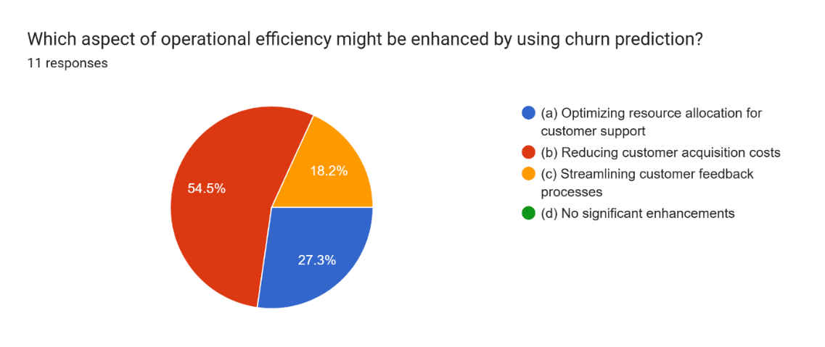

Figure 5.14

This pie chart visualizes responses to the question, “Which aspect of operational efficiency might be enhanced by using churn prediction?” based on feedback from 11 participants. The majority, 54.5%, believed that reducing customer acquisition costs would be the most positively impacted area. Additionally, 27.3% chose optimizing resource allocation for customer support, while 18.2% indicated streamlining customer feedback processes. Notably, no respondents selected “no significant enhancements,” emphasizing a positive perception of churn prediction's operational value.

Interpretation of Results:
Most participants associate churn prediction with the ability to retain customers more effectively, thereby reducing the need to invest heavily in acquiring new ones. The notable selection of resource optimization reflects the idea that predictive insights can help better allocate support staff to high-risk customers. The lower selection for feedback streamlining may imply that while important, it is seen as less directly influenced by churn models.

Research Question: How can churn prediction improve operational efficiency in telecom?
The chart highlights the perceived operational benefits of churn prediction, particularly in lowering acquisition costs—a key efficiency metric in telecom. It confirms that businesses view predictive analytics as a tool to reduce reactive spending by improving retention strategies upfront.

Objective: To determine how big data analytics can enhance operational processes in churn management.
These results support the objective by indicating that churn prediction can transform how resources and budgets are allocated. By focusing on retention over acquisition and optimizing support channels, telecom providers can streamline operations and reduce costs while maintaining customer satisfaction.
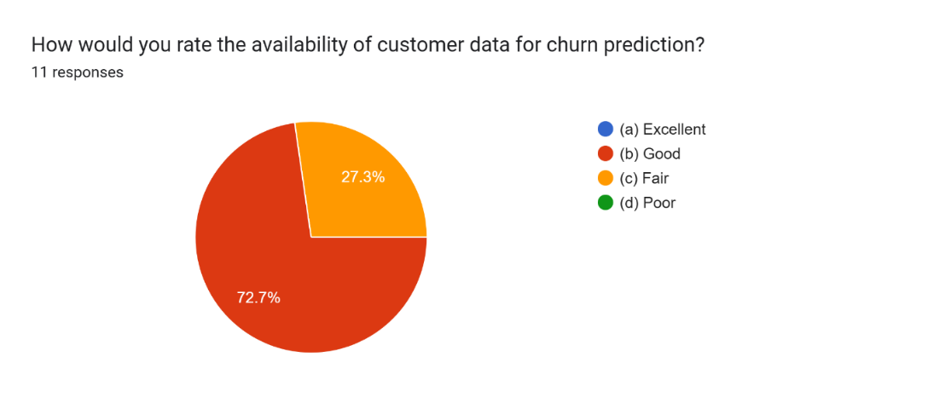

Figure 5.15

This pie chart illustrates participants' perceptions regarding the availability of customer data for churn prediction. Among the 11 respondents, a significant majority of 72.7% rated data availability as “Good”, while 27.3% rated it as “Fair.” Notably, none of the participants rated it as “Excellent” or “Poor,” indicating a consensus around moderate to above-average data access, but with room for improvement.

Interpretation of Results:
The responses reflect a generally positive but cautious outlook on data availability. While most consider data access sufficient for churn modeling, the absence of "Excellent" responses indicates that telecom operators may still face challenges in achieving comprehensive, high-quality, or real-time datasets. This can affect model performance and the precision of customer insights.

Research Question: What are the data-related constraints in building an effective churn prediction model?
This chart directly informs this question by revealing that although data is not a major obstacle, it is also not at an ideal state. A “Good” rating implies basic usability, but not necessarily completeness, diversity, or quality. The presence of “Fair” responses highlights the need for data enrichment and integration strategies.

Objective: To evaluate the readiness of data infrastructure for predictive churn analysis.
The findings meet this objective by providing a stakeholder perspective on data adequacy. It suggests that organizations like Zain JO are equipped to begin predictive analytics initiatives, but further investments in data quality, integration, and feature variety would likely enhance outcomes and model reliability.

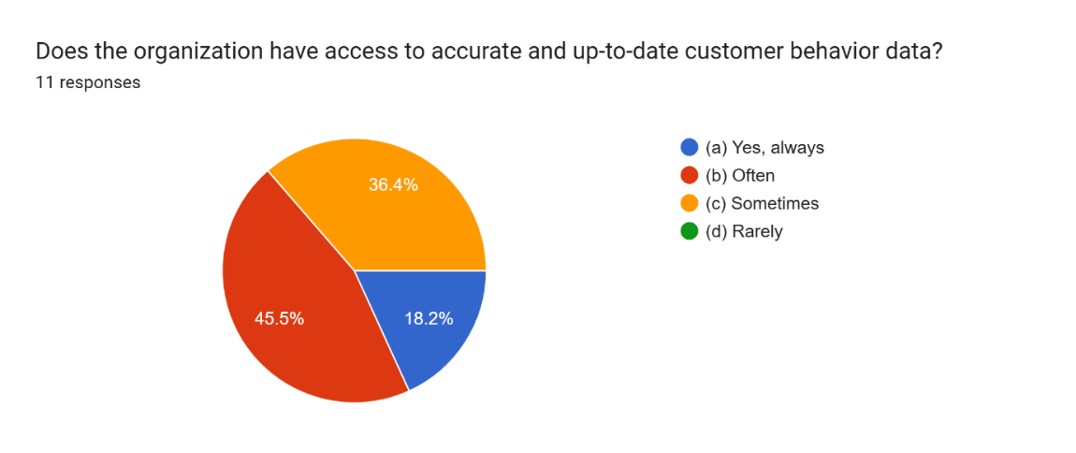

Figure 5.16

This pie chart shows how respondents evaluated their organization's access to accurate and timely customer behavior data. Out of 11 participants, 45.5% stated they “Often” have access, 36.4% indicated access only “Sometimes”, and 18.2% claimed they “Always” have access. No participants selected “Rarely,” suggesting that while access is not perfect, it is generally consistent.

Interpretation of Results:
The distribution reflects moderate reliability in data timeliness and accuracy. Most stakeholders experience frequent access, but a significant portion report variability, implying potential lags or inconsistencies in data collection and integration processes. This inconsistency can affect model accuracy and responsiveness, particularly in churn prediction which requires real-time insights.

Research Question: To what extent is customer behavior data accessible and reliable for churn modeling?
This chart directly supports the research question by highlighting that although access is generally good, it is not uniform or guaranteed. The 36.4% reporting “Sometimes” suggests that data gaps may hinder comprehensive analysis or lead to missed churn signals.

Objective: To determine data readiness and reliability for implementing churn prediction systems.
The responses fulfill this objective by identifying that while systems for behavior tracking are in place, enhancements in data frequency, quality control, and real-time updates could strengthen the foundation for predictive analytics. It emphasizes the need for continuous data pipeline improvement and validation processes.

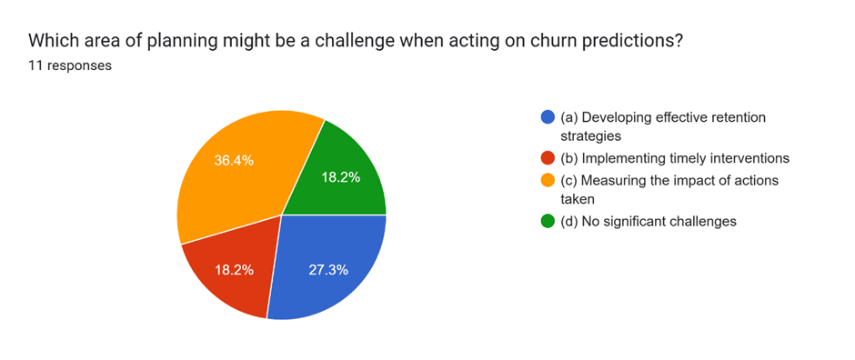

Figure 5.17

This pie chart captures participant views on the biggest planning challenges organizations might face when responding to churn predictions. Among the 11 respondents, the largest proportion, 36.4%, identified “Measuring the impact of actions taken” as the key challenge. 27.3% pointed to “Developing effective retention strategies,” while 18.2% chose “Implementing timely interventions.” Another 18.2% of respondents felt there are no significant challenges in planning.

Interpretation of Results:
The emphasis on difficulty in measuring the impact suggests that while predictive models can identify churn risk, tracking and evaluating the outcomes of responses remains a weak point. Similarly, the significant percentage concerned with strategy development and timely implementation highlights that even with predictive signals, executing and monitoring interventions remains a challenge.

Research Question: What challenges may arise when integrating churn predictions into organizational planning?
The responses offer direct insight into this question, showing that practical application issues—especially post-action measurement—are a key barrier to fully leveraging churn models.

Objective: Identify operational and strategic gaps that affect the effectiveness of churn prediction initiatives.
The results align with this objective by revealing the need for better post-prediction frameworks, including metrics for intervention success, more agile planning processes, and integrated dashboards or systems that link predictions with action outcomes.

Real-world applications:
- Targeted Customer Retention: By identifying at-risk customers early, telecom companies can proactively offer personalized retention deals, improving customer satisfaction and reducing churn rates.

- Operational Efficiency: Predictive analytics allows telecoms to optimize support resource allocation and reduce unnecessary acquisition spending, as reflected in survey results showing interest in cost-saving operational strategies.

- Customer Experience Enhancement: Faster issue resolution and personalized communication (highlighted in the survey) directly improve service quality and brand loyalty.

Merits:
- Data-Driven Insights: The study combined machine learning clustering with employee perception surveys, giving both quantitative and qualitative insights.

- Customer Segmentation: Clustering revealed nuanced customer groups, allowing for segment-specific strategies rather than one-size-fits-all approaches.

- Organizational Relevance: Survey questions were designed around internal business use cases, ensuring the findings are actionable for telecom decision-makers.

- Alignment with Objectives: Results clearly aligned with key research questions and objectives, supporting the practical value of churn prediction.

- Cross-Functional Impact: Findings show that churn analytics supports not just marketing, but operations, planning, and customer service.

Limitations:
- Limited Sample Size: The survey had only 11 respondents, which may not represent the full diversity of organizational views.

- Feature Interpretability: Some cluster features, especially from categorical one-hot encoded variables, may be difficult to interpret without contextual data (e.g., exact city characteristics).

- Static Model: The clustering and churn predictions are based on a static snapshot; real-world churn behavior is dynamic and may shift due to external factors (e.g., economic trends).

- PCA Dimensionality Tradeoff: While PCA reduced noise, it may also obscure meaningful feature interactions, slightly lowering model explainability.

- Silhouette Score Range: The maximum silhouette score achieved (~0.4) indicates only moderate clustering performance, which limits the confidence in segment distinctions.

Conclusion and Recommendations
- State the aim of the study and summarize the findings.
- Based on the findings, discuss the recommendations that you have.
- Propose future work (optional).

This study's main goal was to investigate how the telecom industry might use AI and ML to detect and lower customer attrition. The study aimed to identify practical trends and insights for customer retention, operational enhancement, and strategic planning by using clustering algorithms and gathering survey responses from experts in the field.
Seven different categories of customers were identified by the clustering study based on telecom use characteristics and demographics. Every cluster displayed distinct behavioral characteristics that can guide customized retention tactics, such as telecom provider preference and city association. The complex nature of how customers act in this area is shown by the model's maximum silhouette score of almost 0.18, which indicates a considerable degree of cluster separation.

Recommendations:

- Implement Proactive Retention Strategies: Use model outputs to engage at-risk customers through targeted communications, personalized offers, and pre-emptive service interventions.

- Enhance Data Infrastructure: Maintain access to up-to-date and accurate customer behavior data, as only 18.2% of respondents confirmed always having such access. Regular data audits and integration of real-time sources are essential.

- Invest in Operational Readiness: Optimize support resources and plan retention strategies with analytics-driven decision-making. Align team capabilities with predictive model outputs to act in a timely and measurable way.

- Expand Predictive Analytics Use: Beyond churn, organizations should explore customer segmentation and sales forecasting, which were rated highly in the survey, to drive growth and improve resource allocation.

- Address Planning Challenges: Nearly 36.4% of respondents indicated that measuring the impact of churn interventions is difficult. Future systems should integrate feedback loops to monitor the results of churn-reduction efforts.

Future work:
Further research should include time-series analysis and customer lifetime value (CLV) prediction to capture the evolving nature of churn behavior. Additionally, increasing the size and diversity of survey respondents can enhance the validity and generalizability of insights.

Reflections
- Avoid generalization and focus on personal development and the research journey in a critical and objective way.

Selected Research Methodology

- Reflection of the research process.
- Reflection on the merits, limitations, and potential pitfalls of the selected methods.

A quantitative mono-method approach focused on clustering-based unsupervised learning techniques was selected as the study's methodology. This choice was supported by the purpose of the study's goal, which was to use demographic and behavioral characteristics to divide up telecom users into high-risk churn groups. Efficient analysis and visual interpretation of complex customer patterns across a large set of data were made possible by the application of K-Means and PCA. Measurable confirmation of the quality of clustering was given by quantitative measures like the Davies–Bouldin Index and Silhouette Score.

By the use of data-driven insights and statistically verified conclusions, this technique supported the positivist philosophy of the study. Since the goal of the study was to verify and evaluate assumptions on customer churn behavior in the telecom sector, it also fit with a deductive reasoning approach.

But there were limitations to this method as well. Clustering was able to uncover underlying behavioral patterns, but it was not very effective at explaining the causes of churn. The study would not have been able to get operational, emotional, or experiential insights from customers themselves without qualitative data from focus groups or interviews. Furthermore, even with strong algorithms, accurate segmentation was challenging due to the dataset's complicated and churned customers behaviors, as indicated by the small score 0.18
While its dependence on quantitative-only data limited the depth of insight into consumer reasons and decisions made in organizational applications the technique overall allowed for meaningful segmentation and accomplished the study's technical objectives.

Alternative Research Methodologies

- Alternative research methodologies in view of outcomes.
- Lessons learned in view of outcomes.

While the study employed a quantitative mono-method design, alternative methodologies such as qualitative or mixed-methods approaches could have added valuable depth. A qualitative approach such as conducting interviews or focus groups with telecom customers would have offered richer insights into the emotional and behavioral drivers of churn. This method could uncover motivations behind customer dissatisfaction that are not visible in numerical datasets, such as frustrations with service quality, brand perception, or customer support experiences.
A mixed-methods approach would have combined the strengths of both quantitative clustering and qualitative feedback. For instance, after identifying churn-prone clusters, follow-up interviews with customers from these groups could provide context and explanation for their behavior. Similarly, employee interviews across more departments (not just surveys) could offer strategic-level perspectives on retention challenges.
These alternative methods, however, come with trade-offs. Qualitative methods are time-consuming and may lack generalizability due to small sample sizes. Mixed methods require careful integration and significantly more resources. Given the project’s time constraints, scope, and dataset availability, the mono-method quantitative design was a practical and justified choice. Still, future studies could adopt a mixed-method strategy to gain both predictive power and explanatory richness, especially if organizational access to customers is feasible.

Recommended Actions and Future Considerations

- Use reflection to inform future considerations.
Reflecting on the research process, several actions could enhance future projects of a similar nature. First, increasing the sample size for primary data collection would provide more statistically meaningful insights. The current survey responses were informative but limited in number (n = 11), which constrained generalizability across the telecom workforce. Future research should aim for wider organizational coverage, potentially including external stakeholders such as customers.
Second, the use of additional clustering techniques, such as DBSCAN or hierarchical clustering, could offer alternative perspectives on customer groupings. These methods can handle noise and uneven cluster shapes more effectively than K-Means, which may improve segmentation evaluation metrics and interpretability. (Schubert et al., 2017).
Third, integrating explainable AI (XAI) methods, such as SHAP or LIME, into the clustering analysis could improve the transparency of why certain features lead to certain customer groups. This is particularly important in real-world business adoption, where interpretability is often as valuable as accuracy. (Molnar, 2022).
Additionally, expanding the dimensionality reduction approach beyond PCA—such as using t-SNE or UMAP for better visual clarity—could assist stakeholders in interpreting cluster structures more intuitively. (McInnes et al., 2018; van der Maaten & Hinton, 2008).
Lastly, improvements to data preprocessing ( handling of outliers, missing data imputation instead of row removal) would preserve more data points and potentially enhance model robustness.

Recommended Methodology

- Updated version of paper Methodology (flowchart, block diagram) with discussion.

For future iterations of this project, I would adopt a mixed-methods approach to gain both quantitative precision and qualitative understanding. While the current model effectively segmented customers using clustering algorithms, it lacked human insight into why customers might churn. To bridge this gap, qualitative components such as semi-structured interviews or open-ended surveys could be introduced, even within an academic setting, to simulate stakeholder input or represent potential user perspectives.

To better align the study with the regional context, I would also seek to collect or source a Middle East-specific telecom dataset (ideally from Jordan or neighboring markets). This would significantly enhance the relevance of churn segmentation results by reflecting local demographics, usage behaviors, and operator competition patterns more accurately than the existing India-based dataset.

Additionally, I would enhance the data preprocessing pipeline through:
- Advanced outlier detection techniques (e.g., IQR, Isolation Forest) to preserve useful data points.
- Imputation strategies to handle missing values instead of dropping entire rows, maintaining data richness.
- Feature scaling techniques tailored to clustering (e.g., RobustScaler for non-normal distributions).
- On the modeling side, I would expand beyond K-Means by integrating algorithms such as DBSCAN and Hierarchical Clustering, which are more suitable for detecting complex cluster shapes and varying densities. I would also implement multiple evaluation metrics across multiple runs to improve result stability.
- Finally, the use of explainable AI tools like SHAP would help interpret the contribution of each feature in forming clusters, supporting better decision-making, even in academic demonstrations.
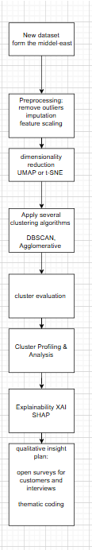
References
- Harvard References
- Sharma, A. and Dey, L. (2012) ‘A comparative study of clustering techniques for clustering web pages’, International Journal of Computer Applications, 37(7), pp. 1–5. Available at: https://doi.org/10.5120/4568-6604

- Sahoo, S., Panda, G., Ray, S. and Dash, P. (2024) ‘Customer churn modeling in telecommunication using a novel multi-objective evolutionary clustering-based ensemble learning’, PLOS ONE, 19(4), p. e0303881. https://doi.org/10.1371/journal.pone.0303881

- Verbeke, W., Martens, D., Mues, C. and Baesens, B., 2012. Building comprehensible customer churn prediction models with advanced rule induction techniques. Expert Systems with Applications, 38(3), pp.2354–2364.

- Keramati, A., Jafari-Marandi, R., Aliannejadi, M., Ahmadi, A., Nikzad-Khasmakhi, M. and Mozaffari, M., 2014. Improved churn prediction in telecommunication industry using data mining techniques. Applied Soft Computing, 24, pp.994–1012.

- Tan, P.N., Steinbach, M. and Kumar, V., 2018. Introduction to Data Mining. 2nd ed. Boston: Pearson.

- Pedregosa, F. et al., 2011. Scikit-learn: Machine learning in Python. Journal of Machine Learning Research, 12, pp.2825–2830.

- Gandomi, A. and Haider, M., 2015. Beyond the hype: Big data concepts, methods, and analytics. International Journal of Information Management, 35(2), pp.137–144.

- Biecek, P. and Burzykowski, T., 2021. Explanatory Model Analysis. CRC Press.

- Rousseeuw, P.J., 1987. Silhouettes: a graphical aid to the interpretation and validation of cluster analysis. Journal of Computational and Applied Mathematics, 20, pp.53–65.

- Calinski, T. and Harabasz, J., 1974. A dendrite method for cluster analysis. Communications in Statistics, 3(1), pp.1–27.

- Davies, D.L. and Bouldin, D.W., 1979. A cluster separation measure. IEEE Transactions on Pattern Analysis and Machine Intelligence, PAMI-1(2), pp.224–227.

- Ribeiro, M.T., Singh, S. and Guestrin, C., 2016. "Why should I trust you?": Explaining the predictions of any classifier. In: Proceedings of the 22nd ACM SIGKDD International Conference on Knowledge Discovery and Data Mining, pp.1135–1144.

- Ahmad, M.A., 2022. Big data analytics for customer churn prediction in the telecommunications sector. International Journal of Computer Applications, 184(7), pp.22–29.

- Al-Nawayseh, M.K. and Al-Muhtaseb, H., 2021. Utilizing machine learning to improve churn detection: A telecom case study in Jordan. Journal of Big Data, 8(45), pp.1–16.

- Baihaqi, A., Mulyanto, A. and Santosa, P.I., 2022. Customer churn prediction using K-means clustering and logistic regression. Procedia Computer Science, 197, pp.670–677.

- Han, J., Pei, J. and Kamber, M., 2011. Data Mining: Concepts and Techniques. 3rd ed. San Francisco: Morgan Kaufmann.

- Huang, B., Kechadi, M.T. and Buckley, B., 2012. Customer churn prediction in telecommunications. Expert Systems with Applications, 39(1), pp.1414–1425.

- Idris, A., Khan, A. and Lee, Y.S., 2012. Intelligent churn prediction in telecom: employing mRMR feature selection and RotBoost based ensemble classification. Applied Intelligence, 39(3), pp.659–672.

- Jafarzadeh, M., Ahmadi, M. and Anari, H., 2017. A study on customer churn prediction in the telecommunication industry using data mining. Journal of AI and Data Mining, 5(2), pp.175–183.

- Li, H., Zhu, J. and Zhang, D., 2019. Customer segmentation and churn prediction based on K-means and decision tree algorithm. Information, 10(3), p.94.

- Moeyersoms, J. and Martens, D., 2015. Including high-cardinality attributes in predictive models: A case study in churn prediction in the energy sector. Decision Support Systems, 72, pp.72–81.

- Neslin, S.A., Gupta, S., Kamakura, W., Lu, J. and Mason, C.H., 2006. Defection detection: Measuring and understanding the predictive accuracy of customer churn models. Journal of Marketing Research, 43(2), pp.204–211.

- Rosset, S., Neumann, E. and Eick, U., 2003. Customer lifetime value models for decision support. Data Mining and Knowledge Discovery, 7(3), pp.321–339.

- Sultana, A. and Banu, A.N., 2020. Comparative analysis of clustering algorithms in predicting customer churn. International Journal of Advanced Computer Science and Applications, 11(7), pp.358–364.

- Thakur, R. and Workman, L., 2016. Customer portfolio management using clustering techniques: Telecom churn analysis. Journal of Database Marketing & Customer Strategy Management, 23(3), pp.142–152.

- Vafeiadis, T., Diamantaras, K.I., Sarigiannidis, G. and Chatzisavvas, K.C., 2015. A comparison of machine learning techniques for customer churn prediction. Simulation Modelling Practice and Theory, 55, pp.1–9.

- Verbeke, W., Dejaeger, K., Martens, D., Hur, J. and Baesens, B., 2012. New insights into churn prediction in the telecommunication sector: A profit driven data mining approach. European Journal of Operational Research, 218(1), pp.211–229.

- McInnes, L., Healy, J. & Melville, J., 2018. UMAP: Uniform Manifold Approximation and Projection for Dimension Reduction. arXiv preprint arXiv:1802.03426.

- Molnar, C., 2022. Interpretable Machine Learning. 2nd ed. [online] Available at: https://christophm.github.io/interpretable-ml-book/

- Schubert, E., Sander, J., Ester, M., Kriegel, H.P. & Xu, X., 2017. DBSCAN revisited, revisited: Why and how you should (still) use DBSCAN. ACM Transactions on Database Systems, 42(3), pp.1–21.

- van der Maaten, L. & Hinton, G., 2008. Visualizing data using t-SNE. Journal of Machine Learning Research, 9(Nov), pp.2579–2605.

